**Q 1 : What is software? What is software engineering?**

software : software is set of instruction to be execute by specific task.

Software engineering : develop any software based in to engineering principal.

**Q 2 : Explain types of software ?**

software is five type :

**Type of software**

1. System software : in build in software , this software is no need to install or download. It is already has a system. Ex : chrome , youtube , calculater etc..
2. application software : this software is need to install or download. It is user dependent ex :games , Instagram etc..
3. middleware : interaction or communication between system and application software. ex: excel.
4. Driver software : communication and driver software sharing with high software. Ex : audio driver , video driver.
5. Programming software : execute program compiler and interpreter ex : visual studio , anaconda etc…

**Q 3 : What is SDLC? Explain each phase of SDLC ?**

SDLC(software develop life cycle) this step by step develop any software/product possible time , high quality , within estimate budget.

Each phase of software develop life cycle :

1.planning / requirement gathering : developer takes a project from company or client and gathers requirement and planning project or product from the company or client.

2.Analysis : developer are analysis requirement company or client, developer create software requirement specification(SRS) does not change requirement company or client.

3.Designing : developer work from designing , different 3d model , ER diagram , usercase diagram , flowchart , data flow diagram etc..

4.Implementation/development/building : developer work from backend side a project implementation or development.

5.Testing : client meets the requirement and work as expected , defect testing.

6.Maintenance : maintain the project according to the developer timeprior.

**Q.4 What is DFD? Create a DFD diagram on Flipkart?**

DFD : data flow diagram

Data flow diagram is representing flow of data a level to level.

**LEVEL : 0**

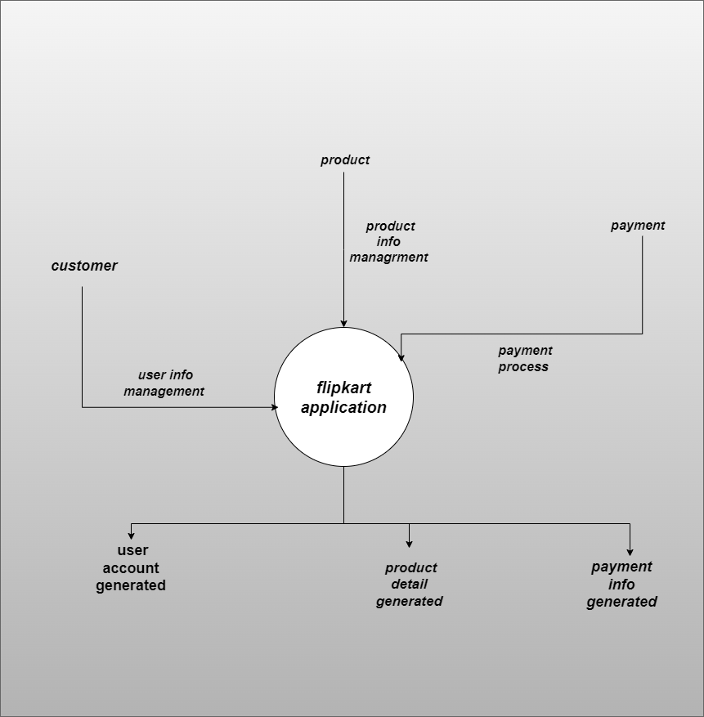

**LEVEL : 1**

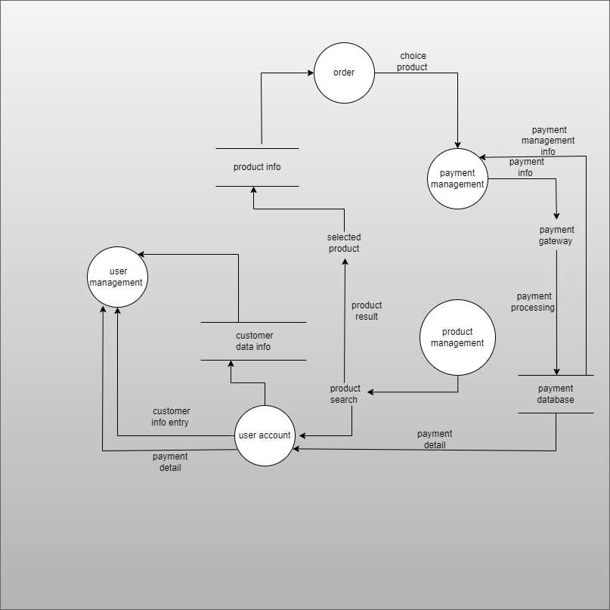

**LEVEL : 2**

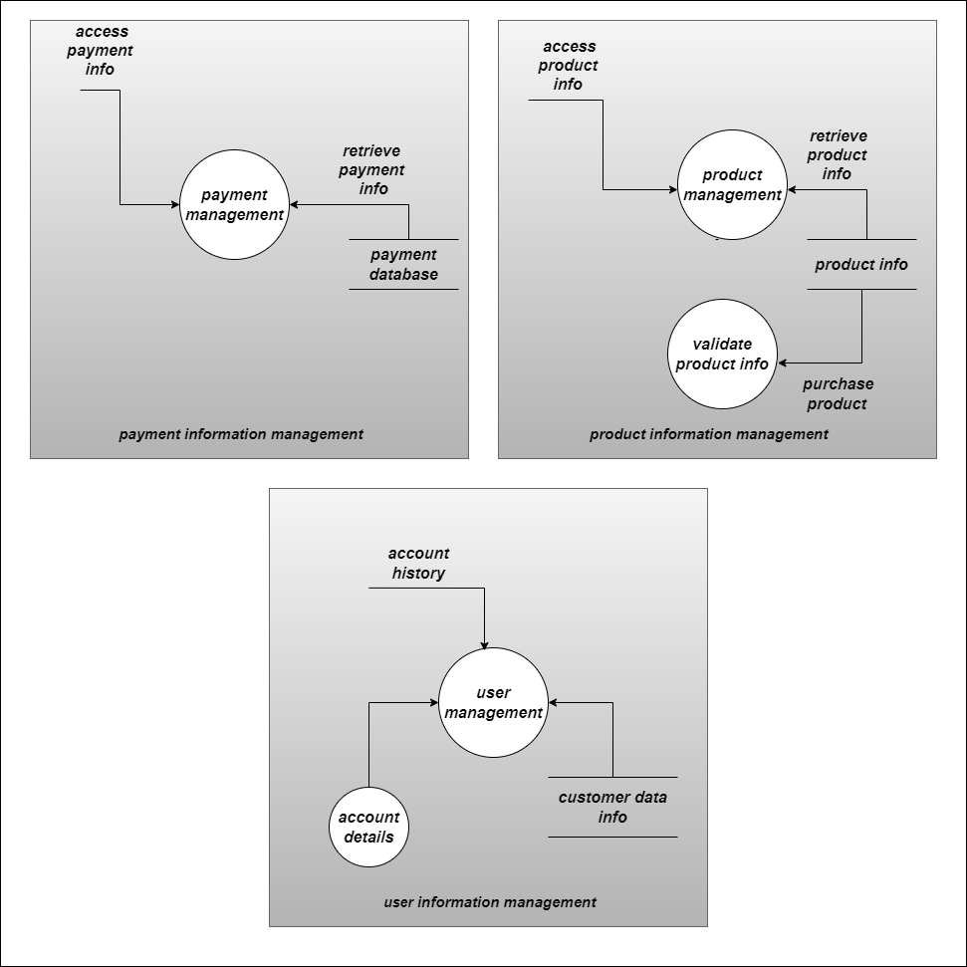

**Q.5 What is flow chart? Create a flowchart to make addition of two numbers ?**

flowchart is graphical representation to a algorithm.

flowchart is step , sequence , decision to a workflow.

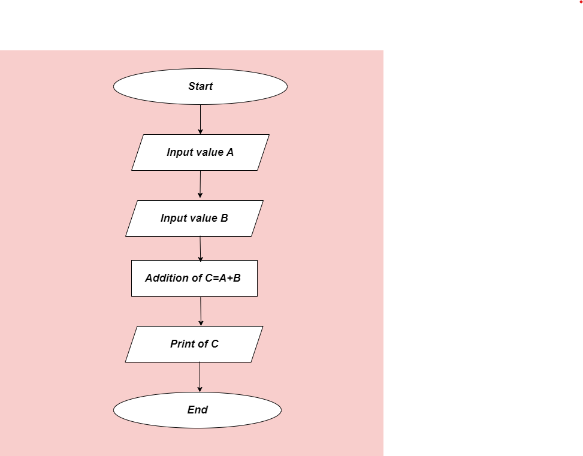

**Q 6 : What is Use case Diagram? Create a use-case on bill payment on paytm.**

sequence of action perform bay the actor. Use case diagram is refer step bay step.

Mainly three type components :

* + Action
  + Actor
  + Link

